**DAILY ONLINE ACTIVITIES SUMMARY**

|  |  |  |  |  |  |  |  |
| --- | --- | --- | --- | --- | --- | --- | --- |
| **Date:** | **19/05/2020** | | | | **Name:** | **Pratibha shetti** | |
| **Sem & Sec** | **4th SEM 'B' Section** | | | | **USN:** | **4AL18CS062** | |
| **Online Test Summary** | | | | | | | |
| **Subject** | | **Design and Analysis of Algorithms** | | | | | |
| **Max. Marks** | | **30** | | **Score** | | **08** | |
| **Certification Course Summary** | | | | | | | |
| **Course** | **Python for machine learning** | | | | | | |
| **Certificate Provider** | | | **Great Learning Academy** | **Duration** | | | **5 hours** |
| **Coding Challenges** | | | | | | | |
| **Problem Statement:** A user will input two strings, and we find if one of the strings is a sub sequence of the other. Program prints “yes” if either the first string is a sub sequence of the second string or the second string is a sub sequence of the first string. Assume that, the length of the first string is smaller than or equal to the length of the second string. Assume that, the length of the first string is smaller than or equal to the length of the second string. | | | | | | | |
| **Status: completed** | | | | | | | |
| **Uploaded the report in Github** | | | | **yes** | | | |
| **If yes Repository name** | | | | <https://github.com/pratibhashetty-123/Lockdown-coding> | | | |
| **Uploaded the report in slack** | | | | **yes** | | | |

Online Test Details: (Attach the snapshot and briefly write the report for the same)

Certification Course Details: (Attach the snapshot and briefly write the report for the same)

Coding Challenges Details: (Attach the snapshot and briefly write the report for the same)

ONLINE TEST DETAILS:

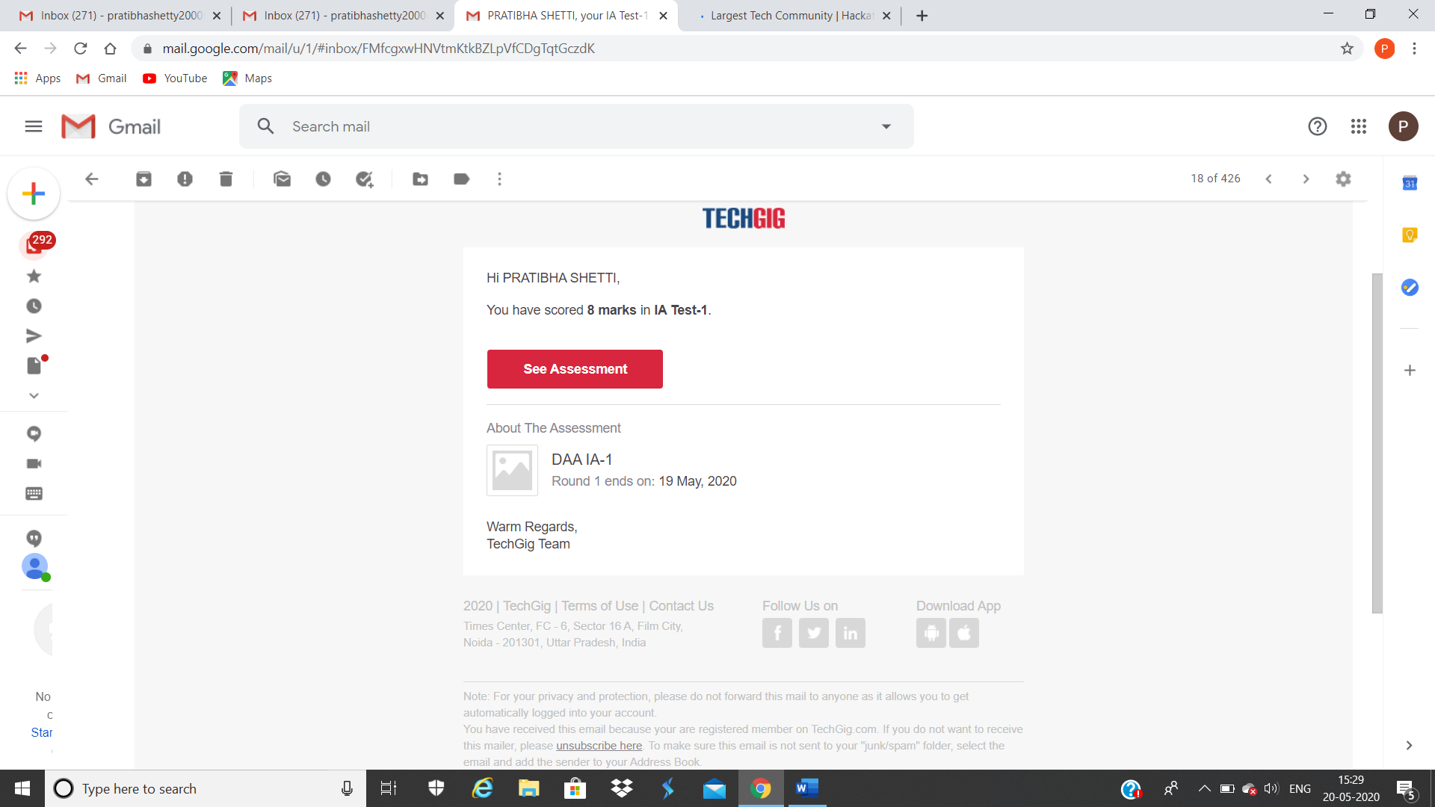

CERTIFICATION COURSE DETAILS:

Online Certification course Summary: I have opted my Online Certification Course in Great learning academy the course which I have opted is Python for Machine Learning. Course contains assessments and practice assessments the faculty is Dan Mitchell-Assistant professor, university of Minnesota; Industrial and Systems Engineering. Today I have gone through the python introduction and I came to know that python is easy to learn , powerful programming language. We can also use python when our data analysis task needs to be incorporated into a production database. B Being a full-fledged programming language, it’s a great tool to implement algorithms for production use.

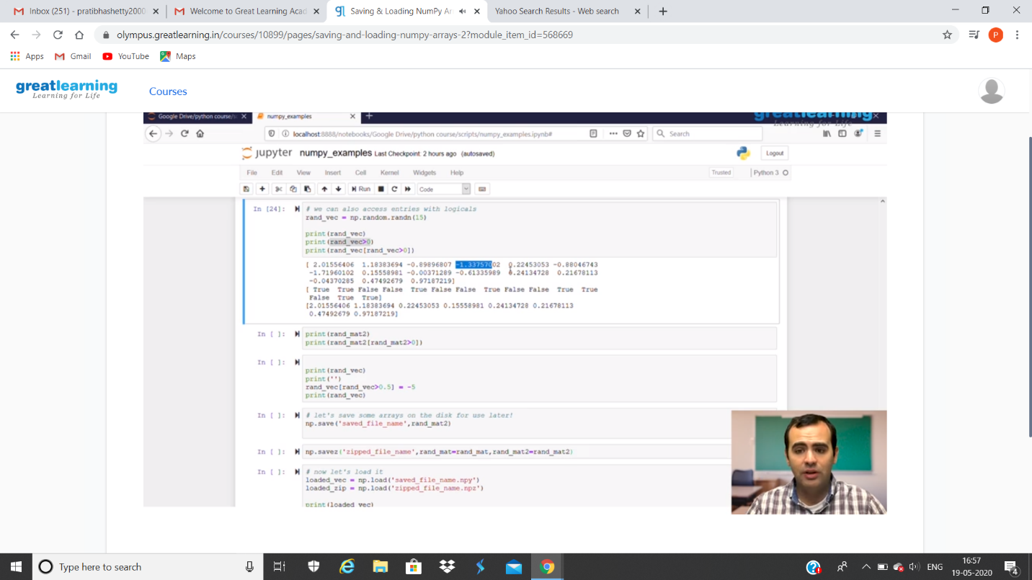

CODING CHALLENGES DETAILS:

Problem statement 1:

A user will input two strings, and we find if one of the strings is a sub sequence of the other. Program prints “yes” if either the first string is a sub sequence of the second string or the second string is a sub sequence of the first string.  
Assume that, the length of the first string is smaller than or equal to the length of the second string.

**An expected output of the program:**

Input the first string  
tree  
Input the second string  
Computer science is awesome  
YES

Solution : Uploaded it in github

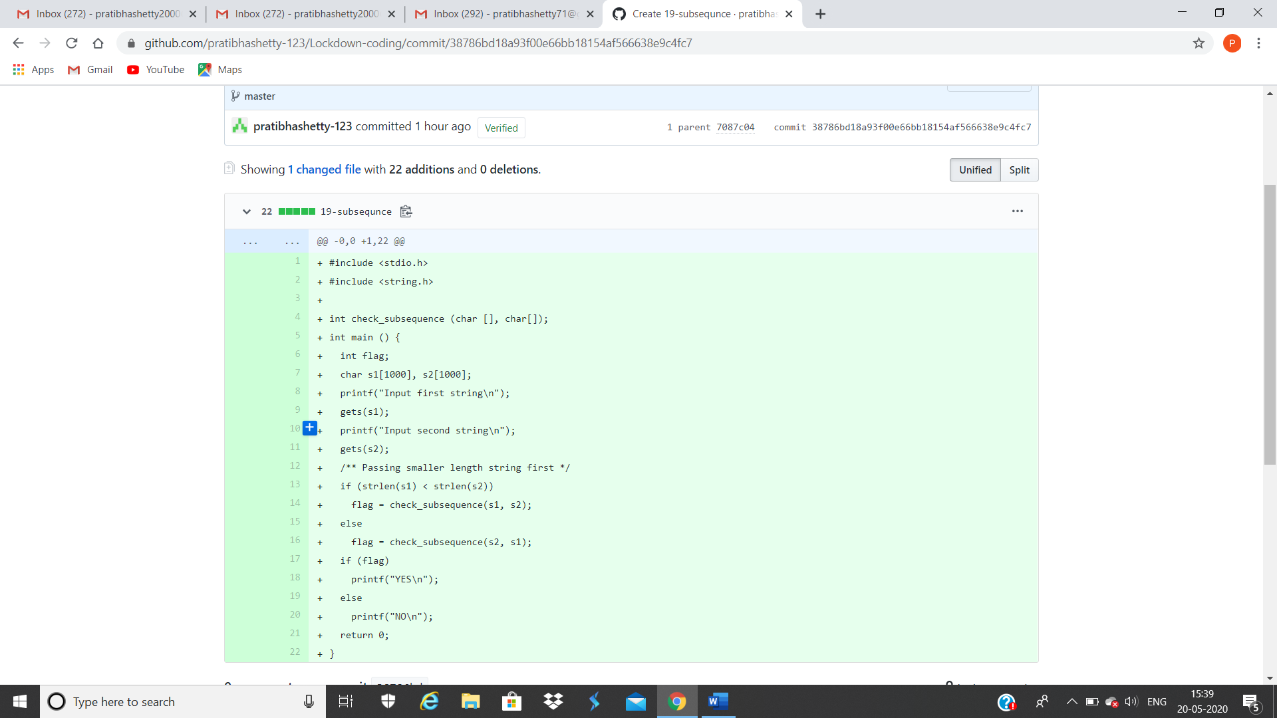

Problem statement 2:

We have a Letter or a word then we need add some letters to it and need to find out shortest palindrome  
For example we take "S": S will be the shortest palindrome string.  
If we take "xyz": zyxyz will be the shortest palindrome string  
So we need to add some characters to the given string or character and find out what will be the shortest palindrome string by using simple java program.

Solution: Uploaded in github.

